Directions from Hotel to Kathy and Jon’s House
244 Austin St., Newton, MA 02465

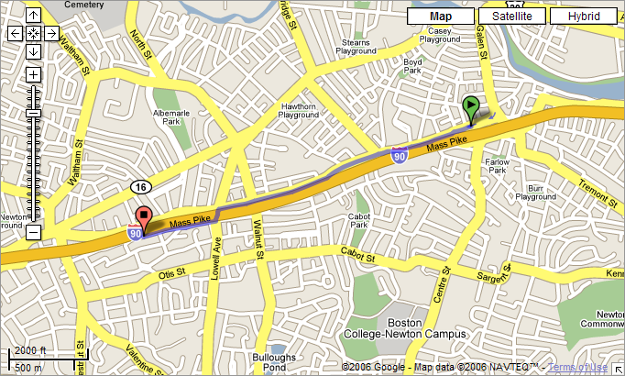

- Turn left out of Sheraton Hotel onto Washington St. and go 1.3 miles.
- Turn left on Lowell Ave. (the cross-street after you pass the Shaws over the Mass Pike).
- Turn right immediately after you cross the Mass Pike, onto Austin St., which parallels the Mass Pike.
- Jon and Kathy’s house is about a half-mile on the left.

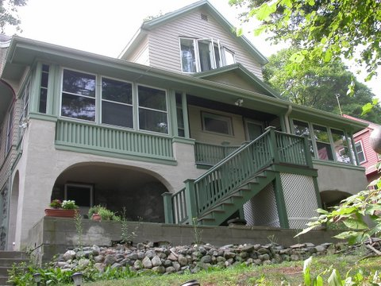

Directions from Hotel to Kathy and Jon’s House
244 Austin St., Newton, MA 02465

- Turn left out of Sheraton Hotel onto Washington St. and go 1.3 miles.
- Turn left on Lowell Ave. (the cross-street after you pass the Shaws over the Mass Pike).
- Turn right immediately after you cross the Mass Pike, onto Austin St., which parallels the Mass Pike.
- Jon and Kathy’s house is about a half-mile on the left.

Shaws over the Mass Pike.
Shaws over the Mass Pike.
Sheraton
Our house
Sheraton
Our house

