Directions from Commander’s Mansion to China Pearl Restaurant
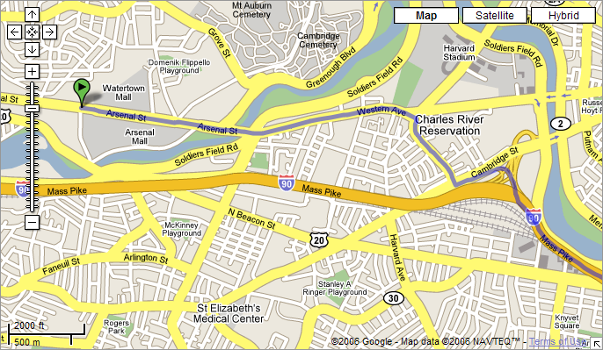
- Turn right out of the Arsenal Plaza onto Arsenal St.
- Cross the river, and go straight through the two intersections, continuing on Western Ave. for 1mi.
- Take the right of the fork at the Exxon gas station (onto Spurr St.) and turn right onto North Harvard St.
- Follow North Harvard St. to the end (~0.4mi.).
- Turn left onto Cambridge St. and follow the sign to get onto I-90 East. The toll is $1.00. Go 3 miles….

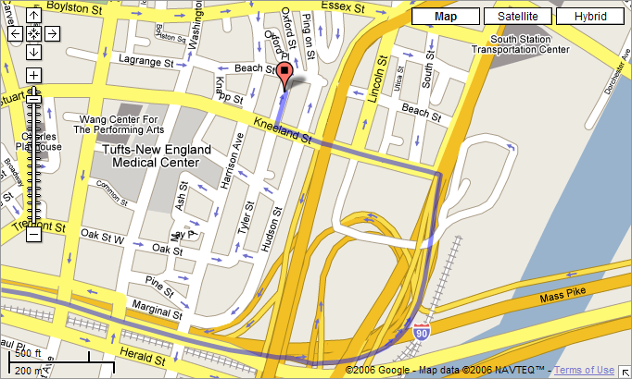
- Take Exit 24A to South Station and stay left on the exit ramp until you reach the light.
- Turn left at the end of the ramp onto Kneeland St.
- Go 0.2mi. and turn right on Tyler St., or head towards parking garages shown on other side of sheet.

Directions from Commander’s Mansion to China Pearl Restaurant
- Turn right out of the Arsenal Plaza onto Arsenal St.
- Cross the river, and go straight through the two intersections, continuing on Western Ave. for 1mi.
- Take the right of the fork at the Exxon gas station (onto Spurr St.) and turn right onto North Harvard St.
- Follow North Harvard St. to the end (~0.4mi.).
- Turn left onto Cambridge St. and follow the sign to get onto I-90 East. The toll is $1.00. Go 3 miles….

- Take Exit 24A to South Station and stay left on the exit ramp until you reach the light.
- Turn left at the end of the ramp onto Kneeland St.
- Go 0.2mi. and turn right on Tyler St., or head towards parking garages shown on other side of sheet.

Toll
Toll

