P2
P1
P3
P2
P1
P3

Parking Options near China Pearl Restaurant

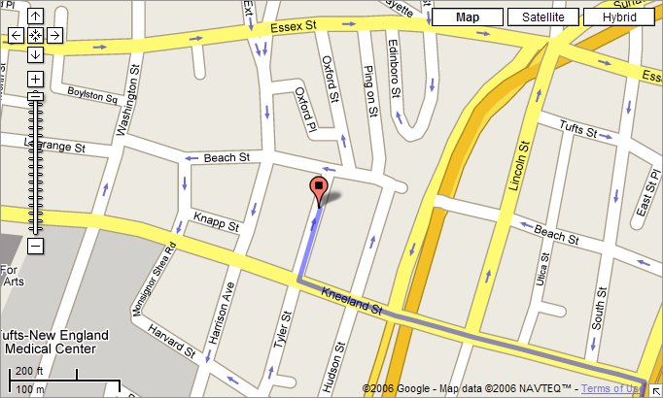

P1 – On Tyler St. a couple doors down from the China Pearl Restaurant. Cost ~$20-$30.

P2 – Parking Garage east of the restaurant. The entrance is on Beach St. Cost $10.

P3 – Parking garage west of the restaurant. Entrance is on Beach St. Cost $8 (with restaurant validation).

P4 – Boston Common Parking Garage (not pictured). About 8 blocks west of the China Pearl Restaurant. Cost $10.

Parking Options near China Pearl Restaurant

P1 – On Tyler St. a couple doors down from the China Pearl Restaurant. Cost ~$20-$30.

P2 – Parking Garage east of the restaurant. The entrance is on Beach St. Cost $10.

P3 – Parking garage west of the restaurant. Entrance is on Beach St. Cost $8 (with restaurant validation).

P4 – Boston Common Parking Garage (not pictured). About 8 blocks west of the China Pearl Restaurant. Cost $10.

